Software Requirements Specification
for
Engleza fara profesor
Prepared by
Elena Gabriela Bogos
Andreea Bianca Caprian
Maria Mesina
1307A
Facultatea de Automatica si Calculatoare, Iasi
May 22, 2020
Table of Contents
Table of Contents
Revision History
1. Introduction
1.1 Purpose
1.2 Document Conventions
1.3 Intended Audience and Reading Suggestions
1.4 Product Scope
1.5 References
2. Overall Description
2.1 Product Perspective
2.2 Product Functions
2.3 User Classes and Characteristics
2.4 Operating Environment
2.5 Design and Implementation Constraints
2.6 User Documentation
2.7 Assumptions and Dependencies
3. External Interface Requirements
3.1 User Interfaces
3.2 Hardware Interfaces
3.3 Software Interfaces
3.4 Communications Interfaces
4. System Features
5. Other Nonfunctional Requirements
5.1 Performance Requirements
5.2 Safety Requirements
5.3 Security Requirements
5.4 Software Quality Attributes
5.5 Business Rules
6. Other Requirements
Appendix A: Glossary
Appendix B: Analysis Models
Appendix C: Scenario

Introduction

Purpose
Engleza Fara Profesor is a self-taught application that helps the user to improve their English vocabulary but also to test their current knowledge. The user has the opportunity to take short tests of ten exercises each. The exercises are of two kinds: to fill-in the translation of a word or to choose the right answer between four possible options. After finishing a test, the user is shown the test result and has the opportunity to check his overall score after all of the tests completed since opening the application.

Document Conventions
This document follows the IEEE standard formatting for software development. The standard defines a regular formatting this document follows including writing to be done in third-person, passive voice as well as readable and grammatically correct text.

Intended Audience and Reading Suggestions
This document contains technical information about the development of the application, in addition to those about its use. Therefore, the target readers of this document are testers or application developers.
A general overview of the application can be found in the second section of the document and more details about its functionality are given in sections 3 and 4.

Product Scope
The application is developed in C#, being connected to a SQLite database. It has a minimalist design and a few buttons that make the test simple to navigate, being intuitive. The exercises are randomly generated such that each test is different and the user never knows what kind of question follows.

References
N/A

Overall Description

Product Perspective
Engleza fara Profesor is not part of a product family and does not imitate an already existing application, but the theme of the project is inspired by mobile language learning applications and the need of the modern world to know English.
It is a Windows Forms App based on a form with multiple panels. Also, it contains a module for the connection to the database and another one for the generation of test. The latter mentioned contains, in general, a class that holds the Course (a test of ten exercises) and its methods of verification, two other classes TranslationExercise, ChoiceExercise that hold the elements of each type of exercise and a ExerciseFactory class that holds the random generation of the two types of exercises.

Product Functions
Major functions that Engleza fara Profesor must perform for its end user is as follows:
- Dynamic completion of a language test – the user has to respond to different kind of exercises before the time expires
- Visualizing the correct answers – before moving on to the next question, the user sees the right answer to the current question
- Global score and improvement – after completing several tests the user can see his global results in order to appreciate his/her progress

User Classes and Characteristics
The presented application is intended for any type of user due to its intuitive elements and easy-to-pass tests for both children and adults or elderly people, because it does not require advanced knowledge of technology.

Operating Environment
The application is made to run on any computer equipped with Windows operating system, without the need to install additional programs.

Design and Implementation Constraints
Since Engleza fara Profesor is being designed and implemented in the second half of a semester as a project for the Software Engineering course, it is possible that time is the most limiting factor in this development cycle. This time constraint may require this team to scale back the project from its initial proposed scope. There are no other limiting factors though, as there is really no cost to development of such a product.

User Documentation
Users will have access to a dedicated documentation directly from the interface of the application through the Help button of the menu strip. This documentation will indicate them how to use the application without exposing programming or implementation details.

Assumptions and Dependencies
The only external impediment that could determine the inability to use the application is the modification of its database by an unapproved person.

External Interface Requirements

User Interfaces
The user interfaces will be displayed in a constant dimension window without the necessity to change its dimensions in order to see all its elements. There will be a menu strip at the top of the window that contains two buttons: one that redirects the user to the help documentation and the other one that displays some details about the application as the title, the year of implementation, and the names of the people who participated to this project. The other elements of the GUI will be as intuitive as possible, having positions chosen to facilitate navigation and very suggestive names. Other details about the user interface design and captures of the application running are available in the extention at the end of this SRS document.

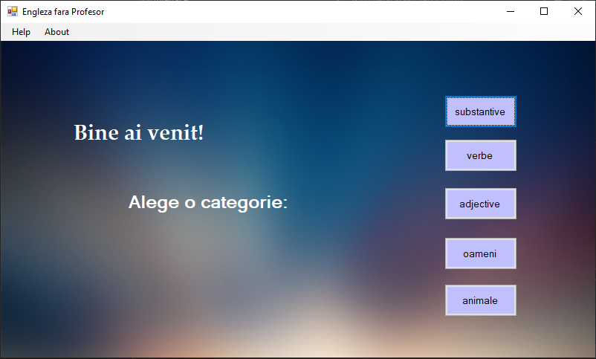

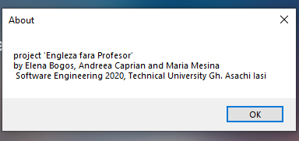

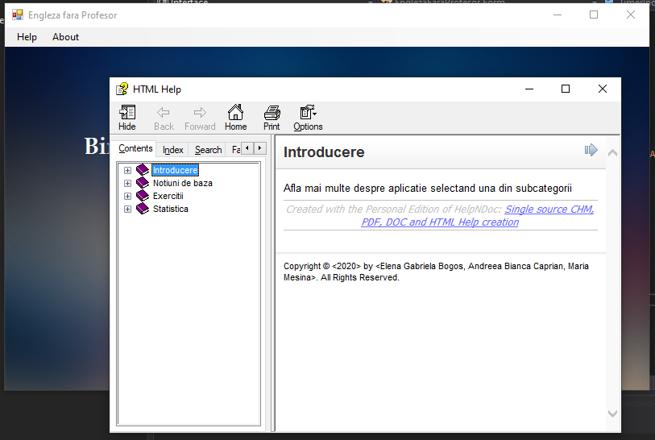

Hardware Interfaces
Hardware interfaces includes a display monitor, a mouse and a keyboard. The mouse will serve the user to navigate through the application, being necessary to press some buttons on the interface. The keyboard will be used only to fill the answer box of the translation exercises.

Software Interfaces
In order to run the application, the user will need to have at least version 4.5 of .NET installed on his computer. If the user does not have this software he can go to https://dotnet.microsoft.com/download/dotnet-framework and download it from there.

Communications Interfaces
Using the Engleza fara Profesor application does not require an internet connection.

System Features
UML diagrams describing the systems’ features are covered in-depth in the appendices from the end of the SRS document including use case, class, activity and sequence diagrams.

Other Nonfunctional Requirements

Performance Requirements
We believe that our application can be used on any edition of Windows starting with Vista SP2. Also, it is recommended to have at least 512 Mb RAM for comfortable usage.

Safety Requirements
Except for the normal safety measures for the usage of the computer, the use of the application does not require additional measures in this respect, not having graphic elements that can affect a person's health.

Security Requirements
Engleza fara Profesor will not collect any private information from users so it does not require special security measures.

Software Quality Attributes
Being a self-learning application, it must be as bug-free as possible and easy to use in order to ensure the users have a positive and useful experience.

Business Rules
It is the policy of the development team to follow all codes of conduct established by the University.

Other Requirements
Appendix A: Glossary
N/A

Appendix B: Analysis Models
Use Case Diagram:
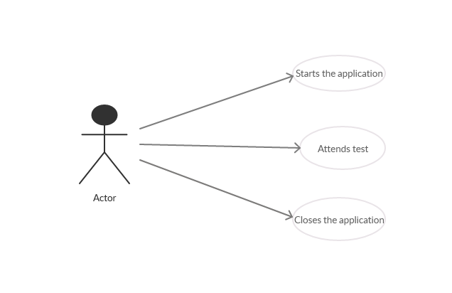
Activity Diagram:
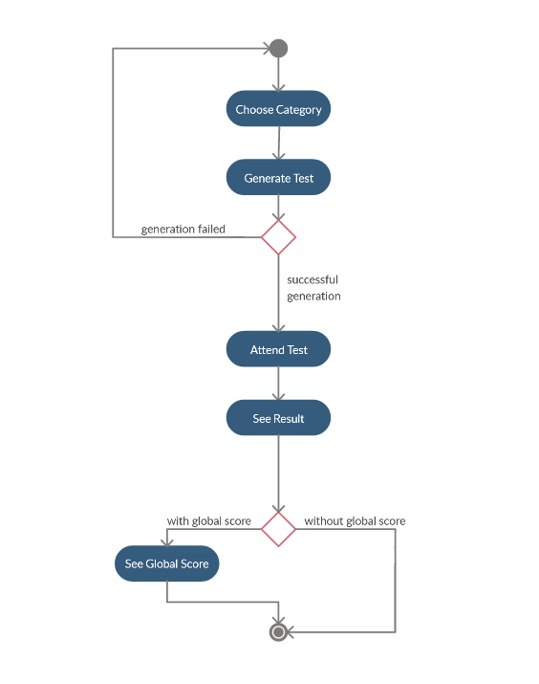

Class Diagram:

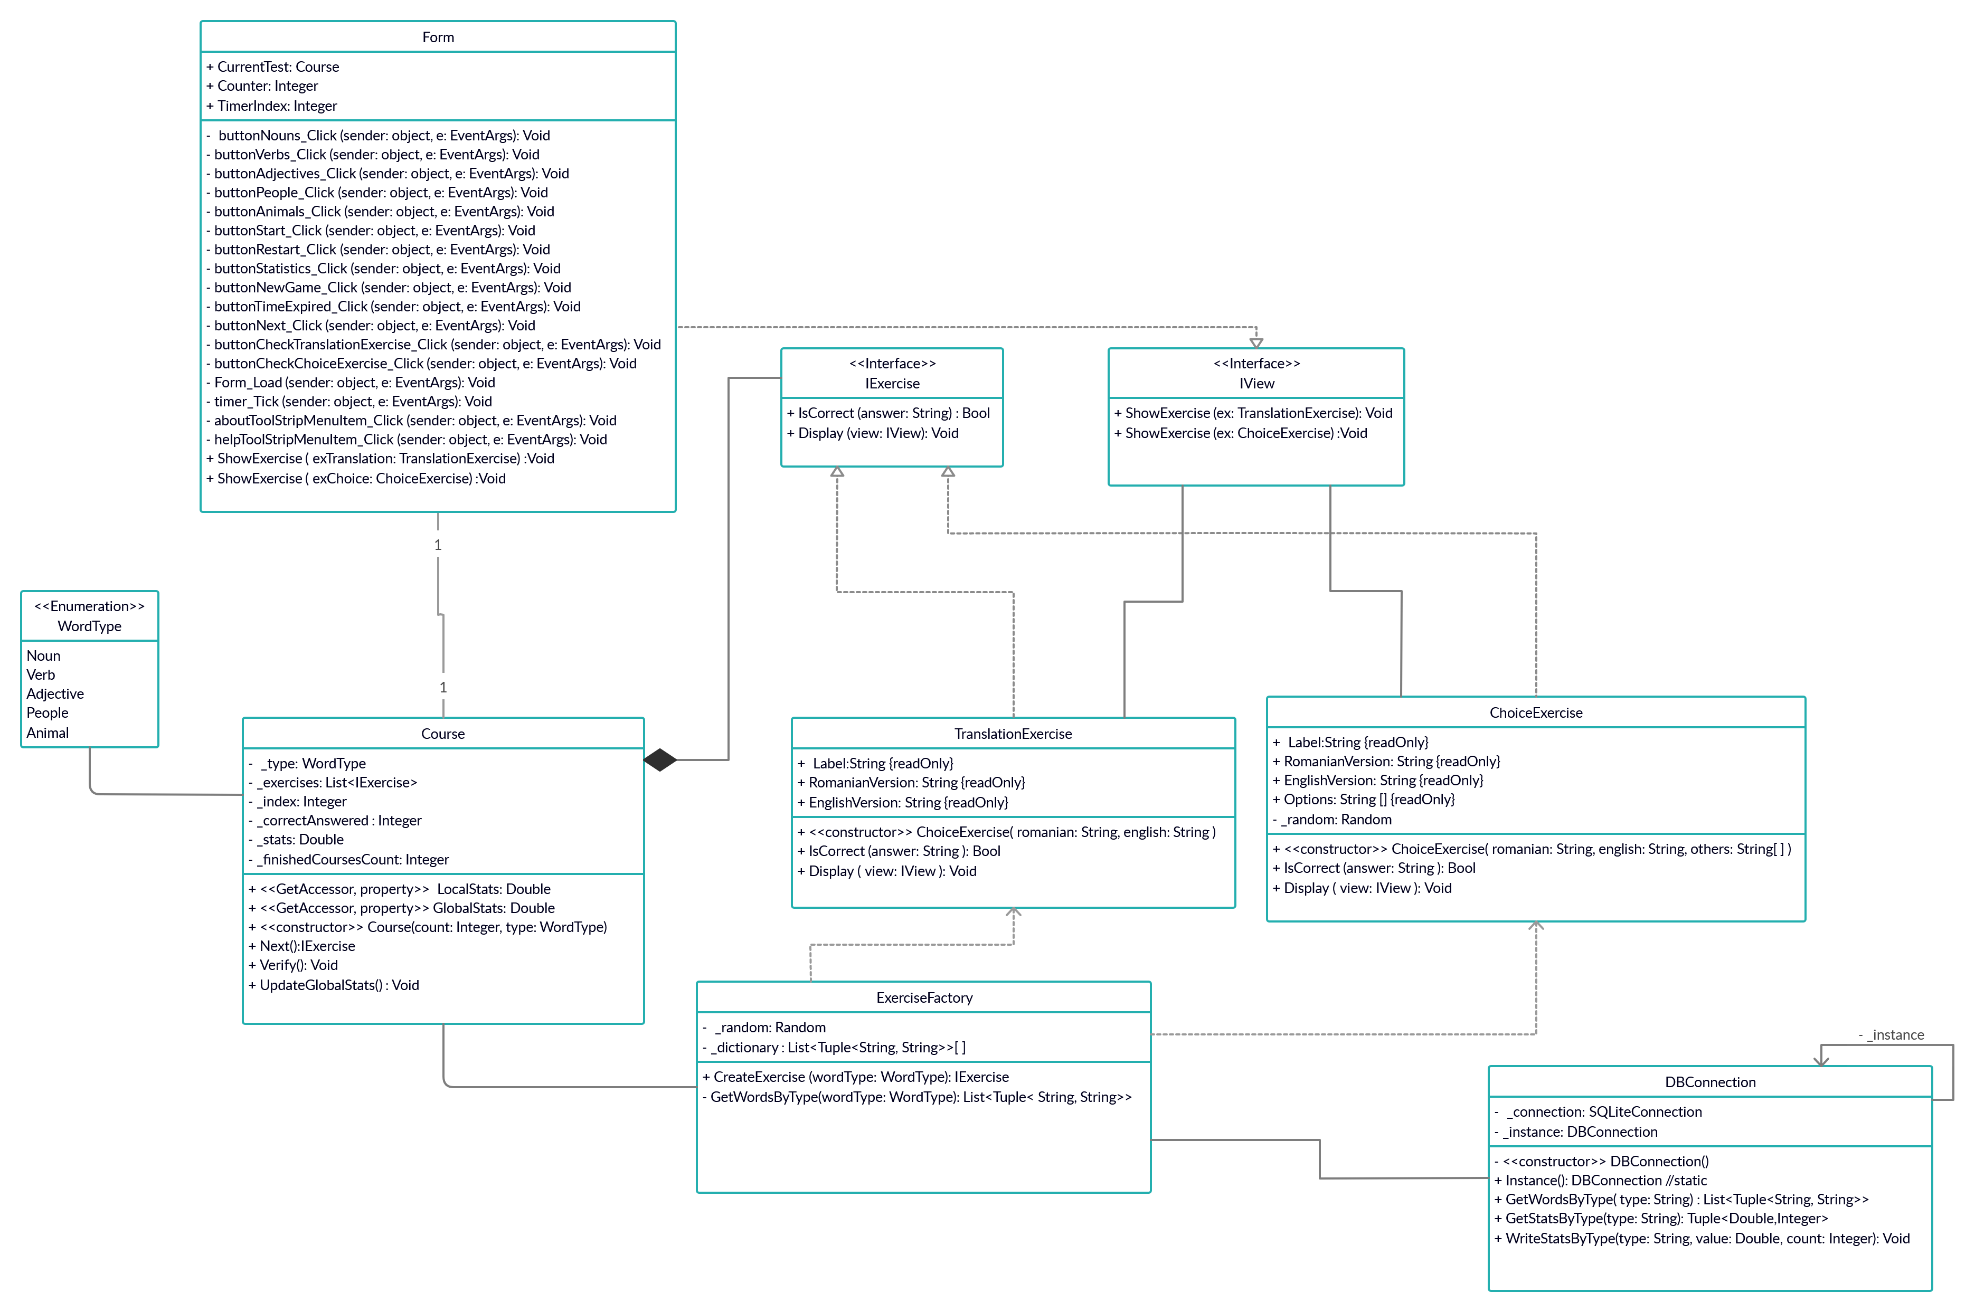

Sequence Diagram:

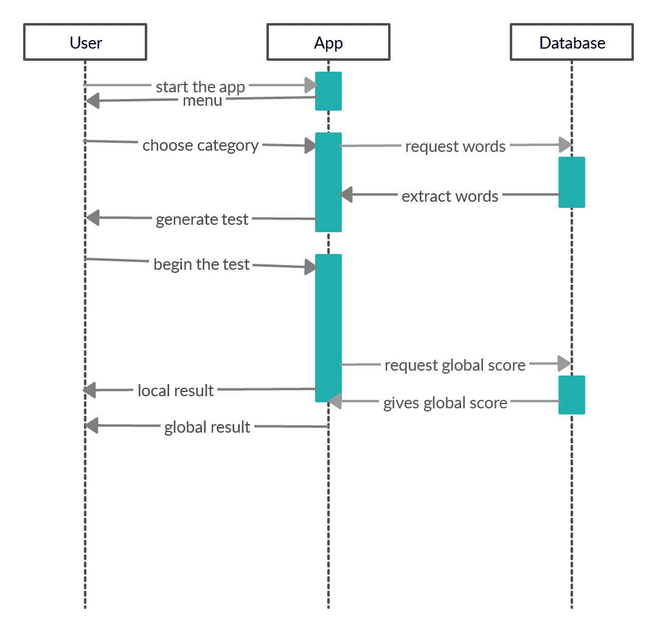

Appendix C: Scenario
The main principle of the Engleza fara Profesor application is to enrich the user's English vocabulary.
The user can choose between 5 categories of words and then to go through a ten-question test including fill-in exercises and multiple-option exercises. The test lasts two minutes and at the end the result is given. More than that, the user has the posibility to check his/her global score based on the number of finished tests in that category and their average score.

Engleza fara Profesor

Descrierea utilizarii aplicatiei din perspectiva utilizatorului,
bazandu-se pe Help-ul atasat programului

Principiul de baza al aplicatiei Engleza fara Profesor este de a imbogati vocabularul in limba engleza a utilizatorului. Din meniul principal se poate alege o categorie de cuvinte dintre: substantive, verbe, adjective, oameni si animale. Testul prezinta doua tipuri de exercitii: unul cu variante de raspuns si unul de completare a raspunsului corect de la tastatura.
Aplicatia afiseaza o numaratoare inversa de 120 secunde, iar daca timpul expira inainte de a finaliza testul, acesta este automat incheiat si exercitiile nerezolvate sunt considerate gresite.
La finalul unui nivel este afisat rezultatul testului si apasand un buton este posibila vizualizarea scorului global.

Capturi de ecran ale programului in executie:

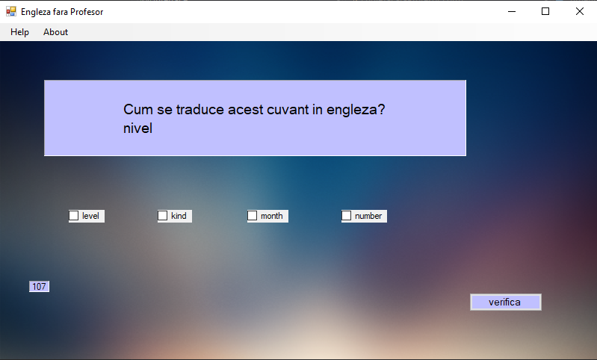

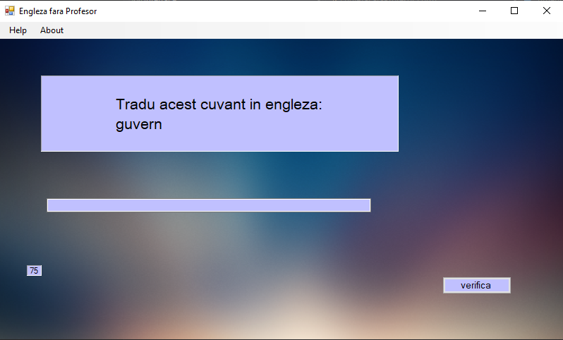

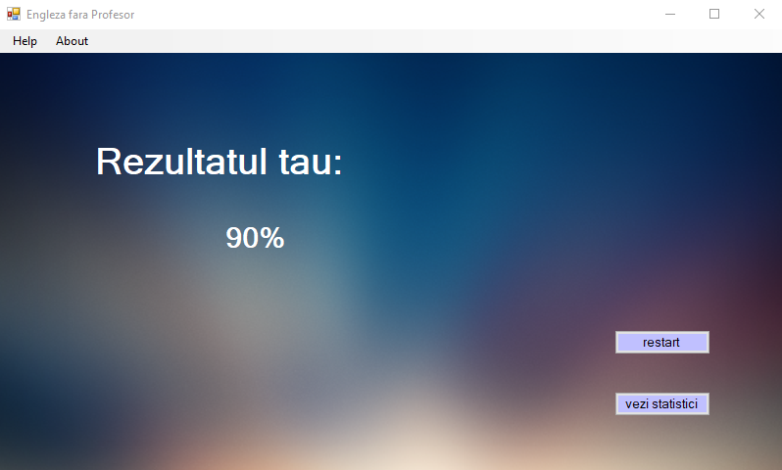

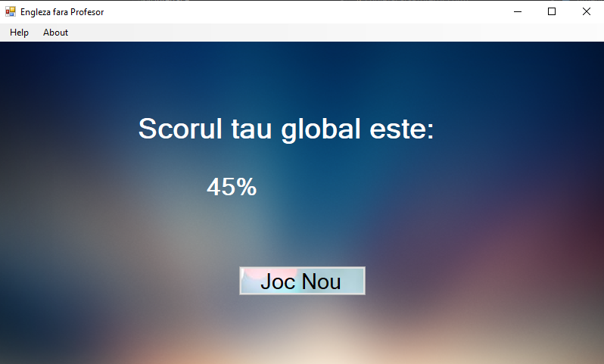

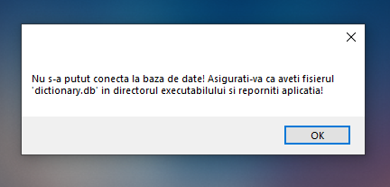

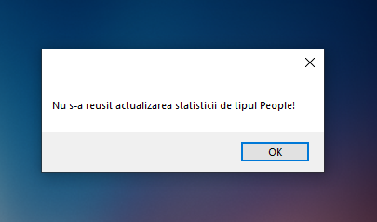

Cod sursa relevant:

// deschide o noua conexiune cu baza de date (fisier 'dictionary.db')
// exceptia "System.InvalidOperationException" este aruncata cand conexiunea cu baza de date nu poate fi deschisa

private DBConnection()
{
SQLiteConnectionStringBuilder cnsb = new SQLiteConnectionStringBuilder()
{
ConnectionString = @"Data Source=dictionary.db;Version=3;Mode=ReadWrite;",
FailIfMissing = true
};

_connection = new SQLiteConnection(cnsb.ToString());
try
{
_connection.Open();
}
catch (SQLiteException)
{
throw new InvalidOperationException("Nu s-a putut conecta la baza de date! Asigurati-va ca aveti fisierul 'dictionary.db' in directorul executabilului si reporniti aplicatia!");
}
}

// realizeaza o cerere la baza de date si extrage toate cuvintele de tipul cerut
// se returneaza o lista de perechi de string-uri reprezentand cuvantul in romana si echivalentul sau in engleza
// exceptia "System.InvalidOperationException" este aruncata cand cererea catre baza de date esueaza sau daca in baza de date datele sunt invalide

public List<Tuple<string,string>> GetWordsByType(string type)
{
List<Tuple<string, string>> dictionary = new List<Tuple<string, string>>();
string stm = $"SELECT * FROM words WHERE type = '{type}'";

var command = new SQLiteCommand(stm, _connection);

try
{
var dataReader = command.ExecuteReader();
while (dataReader.Read())
{
Tuple<string, string> tuple = new Tuple<string, string>(dataReader.GetString(0), dataReader.GetString(1));
dictionary.Add(tuple);
}
dataReader.Close();
return dictionary;
}
catch (InvalidCastException)
{
throw new InvalidOperationException($"Nu s-a reusit incarcarea cuvintelor de tipul { type }! Fisierul 'dictionary.db' este corupt! Asigurati integritatea fisierului si reporniti aplicatia!");
}
catch (SQLiteException)
{
throw new InvalidOperationException($"Nu s-a reusit citirea cuvintelor din baza de date!");
}
}

// instantiere exercitiu de un tip ales random
// wordType specifica tipul de cuvinte ales
// returneaza un IExercise generic
public static IExercise CreateExercise(WordType wordType)
{

//Verifica daca sunt incarcate cuvintele din categoria ceruta, iar daca nu incearca sa le incarce
//in cazul in care nu se gasesc cuvinte din categoria respectiva, arunca o exceptie

if (_dictionary[(int)wordType] == null)
_dictionary[(int)wordType] = GetWordsByType(wordType);
if (_dictionary[(int)wordType].Count == 0)
throw new ArgumentException($"Nu s-a reusit incarcarea cuvintelor de tipul { wordType.ToString() }!Fisierul 'dictionary.db' este corupt!Asigurati integritatea fisierului si reporniti aplicatia!");

ExerciseType exerciseType = (ExerciseType)_random.Next(Enum.GetNames(typeof(ExerciseType)).Length);

Tuple<string, string> tuple = _dictionary[(int)wordType][_random.Next(0, _dictionary[(int)wordType].Count)];

switch (exerciseType)
{
case ExerciseType.TranslationExercise:
return new TranslationExercise(tuple.Item1, tuple.Item2);

case ExerciseType.ChoiceExercise:
//eroare pentru e evita bucla infinita
if (_dictionary[(int)wordType].Count < 4)
throw new ArgumentException($"Nu sunt destule cuvinte de tipul { wordType.ToString() }!Fisierul 'dictionary.db' este corupt!Asigurati integritatea fisierului si reporniti aplicatia!");

//creare lista de optiuni fara optiuni duplicate
string[] englishWords = new string[4];
for (int i = 0; i < 3; i++)
englishWords[i]=_dictionary[(int)wordType][_random.Next(0, _dictionary[(int)wordType].Count)].Item2;
englishWords[3] = tuple.Item2;
for (int i = 0; i < 3; i++)
while (englishWords[i] == englishWords[i + 1])
englishWords[i+1]=_dictionary[(int)wordType][_random.Next(0, _dictionary[(int)wordType].Count)].Item2;
while((englishWords[0]==englishWords[3])||(englishWords[0]==englishWords[2]))
englishWords[0] = _dictionary[(int)wordType][_random.Next(0, _dictionary[(int)wordType].Count)].Item2;
while (englishWords[1] == englishWords[3])
englishWords[1] = _dictionary[(int)wordType][_random.Next(0, _dictionary[(int)wordType].Count)].Item2;

return new ChoiceExercise(tuple.Item1, tuple.Item2,englishWords);

default:
throw new ArgumentException("Tip de cuvinte nerecunoscut!");
}
}

// interfata Iview este folosita pentru a permite implementari diferite a interfetei cu utilizatorul, facand-o vizibila straturilor superioare pentru a crea view-uri personalizate
// interfata principala trebuie sa implementeze clasa IView astfel incat sa fie afisate tipuri diferite de exercitii

public interface IView
{

// metoda specializata in afisarea exercitiilor TranslateExercise
void ShowExercise(TranslationExercise ex);

// metoda specializata in afisarea exercitiilor ChoiceExercises
void ShowExercise(ChoiceExercise ex);
}

public void ShowExercise(TranslationExercise exTranslation) //afiseaza exercitiu cu spatiu de completat
{
panelTranslationExercise.Show();
labelDisplayQuestion.Text = TranslationExercise.Label + Environment.NewLine + exTranslation.RomanianVersion;
textBoxAnswer.Text = "";
labelCorrectAnswer.Text = exTranslation.EnglishVersion;
TimerIndex = 1;
}

public void ShowExercise(ChoiceExercise exChoice) //afiseaza un exercitiu cu variante de raspuns
{
panelChoiseExercise.Show();

labelQuestion.Text = ChoiceExercise.Label + Environment.NewLine + exChoice.RomanianVersion;
checkBox1.Text = exChoice.Options[0];
checkBox2.Text = exChoice.Options[1];
checkBox3.Text = exChoice.Options[2];
checkBox4.Text = exChoice.Options[3];
checkBox1.Checked = false;
checkBox2.Checked = false;
checkBox3.Checked = false;
checkBox4.Checked = false;
labelCorrectAnswer.Text = exChoice.EnglishVersion;
TimerIndex = 2;
}

